

Personal and Intimate Care Policy

July 2021

* Love
* Resilience
* Humility
* Wisdom

**Intimate Care Policy**

Date – November 2024

Review date – November 2025

Introduction

At St. John the Baptist C of E Primary school we aim to meet the needs of all our children and promote their welfare. We will endeavour to instill the Christian values of love and resilience through the way we all respond to a child that may need support and through the encouragement we give them. We recognise and assist children with intimate care where needed, and ensure that the children are treated with courtesy, dignity and respect at all times. We are committed to ensuring that all staff responsible for the intimate care of children will undertake their duties in a professional manner at all times. The school recognises its duties and responsibilities in relation to the Equalities Act 2010 which requires that any pupil with an impairment that affects his/her ability to carry out day-to-day activities must not be discriminated against.

**What is meant by Intimate care?**

Intimate care is defined as care involving washing, touching or carrying out a procedure to intimate personal areas which some children may need support in doing because of their young age, physical difficulties or other special needs. Where a child has intimate care needs, a designated member of staff takes responsibility to provide their care. We address issues on an individual basis. In most cases such care will involve procedures in relation to personal hygiene and the cleaning of equipment associated with the process as part of a staff member’s duty of care. In the cases of specific procedure only staff suitably trained and assessed as competent will undertake the procedure.

Due to the developmental stages of the children that we work with, we support them with their personal care: reminding the children to go to the toilet, hygiene etc. to develop their independence. As outlined in the foundation stage curriculum, we are responsible for children’s personal care skills, as an essential part of Personal Development, in order to be able to access the rest of the

curriculum.

**Implementation**

**Staff training**

All staff are knowledgeable about intimate care/personal care. They are aware of their responsibilities, relevant policies and the procedures in place (including adhering to Child Protection, Health and Safety and confidentiality). The designated employed adult is trained, DBS checked and has received training for very specific intimate care procedures where relevant. They follow the child’s care plan and they undertake their duties in a professional manner at all times. They are fully aware of best practice including hygiene. If a child requires regular assistance with intimate care, staff meet with the parents to discuss the child’s needs and devise an agreed intimate/personal care

plan. Relevant health personnel are involved if needed. We monitor and review the plan on a regular basis.

**Practice**

The designated practitioner who provides the care (in most cases: the child’s key person) forms a strong, trusting relationship with the child. They ensure that it is a positive experience that is safe and comfortable for all. Whilst the child is having their needs met, it is treated as a time to converse and promote their personal development. An individual member of staff will inform another appropriate adult when they are going alone to assist a pupil with intimate care. The child is encouraged to undertake as much of the procedure for themselves as possible, including washing intimate areas, dressing/undressing and hygiene. The children’s toilet area is used to attend to a child’s needs and every effort is made to ensure privacy and modesty. Most procedures are carried out by just the designated person. However, careful consideration is given to the child’s individual circumstances to determine how many practitioners might need to be present when a child needs help with intimate care. If a child is unhappy or anxious about the care being provided, the issue will be addressed to ensure that we continually meet a child’s needs. On some occasions, children come to our setting in nappies. We support children sensitively and with dignity in this matter. Also, from time to time some children will have accidents and need to be attended to. Parents may be asked to provide a spare set of clothing. These are taken into the toilet facilities prior to changing. However, a supply of spare clothing is available if necessary and parents are asked to return these to the school as soon as possible.

Disposal of nappies, aprons and gloves safely - We have in place good hygiene practices when disposing waste to stop infection. We follow stringent nappy changing procedures to ensure the safe disposal of waste, see below. Changing a nappy - A clean disposable apron and gloves are worn by the member of staff every time a child is changed and hands are washed thoroughly after use. Whilst changing, children’s skin is cleaned with a disposable wipe/creams if needed. Nappies and ’pull ups’, gloves, aprons and wipes are disposed of hygienically and safely by bagging and placing in a special bin, which is emptied regularly.

Pupils who require regular assistance with intimate care have written plans (see attached) that identify the support of intimate or personal care agreed by staff, parents and any other professionals actively involved, such as school nurses or physiotherapists. Ideally plans should be agreed at a meeting at which all key staff are present wherever possible and appropriate. The pupils may also be invited to attend. Any historical concerns (such as past abuse) should be taken into account. The plan should be reviewed as necessary, but at least annually, and where there is a change of circumstance, e.g. for residential trips or staff changes (where the staff member concerned is providing intimate care). They should also take into account procedures for off-site visits. Where a suitable care plan is not in place, parents will be informed the same day if their child has needed help with meeting intimate care needs (e.g. has had an ‘accident’ and wet or soiled him/herself). Information on intimate care will be treated as confidential and communicated in person, by telephone or by way of a face to face conversation at the end of the day. In relation to record keeping, a written record should be kept in a format agreed by parents and staff every time a child has an invasive medical procedure, e.g. support with catheter usage. Accurate

records should also be kept when a child requires regular assistance with intimate care; these can be brief but should, as a minimum, include full date, times and any comments such as changes in the child’s behavior (see attached). It should be clear who was present in every case. These records will be kept in the child’s file and available to parents on request.

There must be careful communication with each pupil who needs help with intimate care in line with their preferred means of communication (verbal, symbolic, etc.) to discuss their needs and preferences. Wherever possible, the pupil’s wishes and feelings should be sought and taken into account. Where the pupil is of an appropriate age and level of understanding permission should be sought before starting an intimate procedure. The child will be supported to achieve the highest

level of autonomy that is possible given their ages and abilities. Staff will encourage each child to do as much for him/herself as he/she can. This may mean, for example, giving the child responsibility for washing themselves. Intimate care plans will be drawn up for particular children as appropriate to suit the circumstances of the individual. Each child's right to privacy will be respected. Careful consideration will be given to each child’s situation to determine how many carers might need to be present when a child is toileted. Where possible a child will be catered for by one adult unless there is sound reason for having more than one adult present. If this is the case, the reasons should be clearly documented.

**Working with parents**

We work closely with parents to identify and ensure we meet the child’s needs. Cultural and religious values are respected when planning for their care. We seek to engage in regular communication with parents, and monitor and review the plan together. The needs and wishes of the children and parents will be taken into account wherever possible within the constraints of staffing and equal opportunities legislation.

**Working with outside agencies**

We work closely with outside agencies and utilise their knowledge and expertise where necessary. The SENCO coordinates this approach.

**Safeguarding Children**

Safeguarding and Multi Agency Child Protection procedures will be adhered to. All children will be taught personal safety skills carefully matched to their level of ability, development and understanding. If a member of staff has any concerns about physical changes in a child’s presentation, e.g. marks, bruises, soreness etc. she/he will immediately report concerns to the Designated Safeguarding Lead. A clear record of the concern will be completed on CPOMS. The DSL will decide on whether a referral will be made to MASH in line with the school Child Protection Policy. If a child becomes distressed or unhappy about being cared for by a particular member of staff, the matter will be investigated and outcomes recorded. Parents will be contacted at the earliest opportunity as part of this process in order to reach a resolution. Staffing schedules will be

altered until the issue(s) are resolved so that the child’s needs remain paramount. Further advice will be taken from outside agencies if necessary. No member of staff will carry or have access to a mobile phone, camera or similar device whilst providing intimate care. If a child makes an allegation against

a member of staff, all necessary procedures will be followed in line with Keeping Children Safe in

Education, September 2018, the school Child Protection Policy & procedures. This should be

reported to the Head teacher (or Chair of Governors if the allegation is about the Head teacher) who will report the matter to the DO (formerly LADO) in accordance with the school’s Managing Allegations Procedures within the Child Protection Policy. It should not be discussed with any other

members of staff or the member of staff the allegation relates to. Similarly, any adult who has concerns about the conduct of a colleague at the school or about any improper practice will report this to the Head teacher or Designated Safeguarding Lead in accordance with the whistleblowing procedures within the Child Protection Policy. Where a staff member feels that their genuine concerns are not being addressed, they may refer their concerns to MASH directly. All staff should be aware of the school’s confidentiality policy. Sensitive information will be shared only with those who need to know but in line with the DfE ‘Information Sharing – Guidance for Safeguarding

Practitioners’ July 2018 and the school Child Protection Policy.

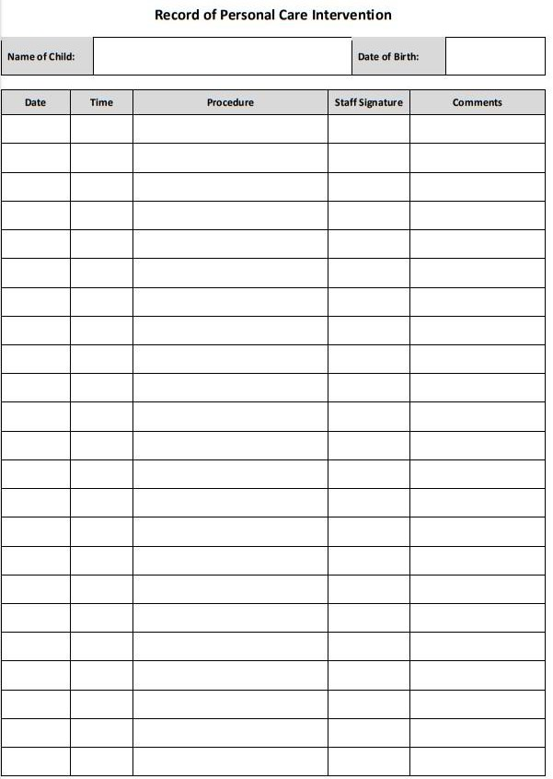

**Personal Care plan for children wearing nappies/pull-ups**

**Child’s Name**: **D.O.B:**

**Completed by (staff)**:

**Parent/Carer**:

**Date of Plan:**

**Who will change the child?**

**How will the child be changed? e.g. standing up in the toilet cubicle, lying down on the changing plinth etc.**

**Who will provide resources? e.g. wipes, nappies etc.**

**Any other comments/important information: e.g. medical information**