**The St. Johns Curriculum**





**‘Life in all its Fullness’**

**(John 10:10)**

At St. John the Baptist Primary School we are passionate about providing our children with the skills and knowledge to be able to live life in all its fullness (John 10:10). This bible verse and indeed our school vision statement has led us to develop a curriculum which aims for every child to fulfil their potential. This means that for the children of St. Johns will grow to:

* Be resilient.
* Have wider experiences.
* Develop healthy relationships.
* Be fulfilled.
* Understand their own spirituality.
* Have an understanding of financial stability.

The Curriculum:

Our curriculum principles are to:

* Develop a rich and deep subject knowledge.
* Learn with a coherent and progressive framework.
* Develop new skills through a variety of interesting contexts.
* Understand the purpose and value of their learning and see its relevance to their past, present, and future.
* See clear links between different aspects of their learning.



See clear links between different aspects of their learning.

Learn with a coherent and progressive framework.

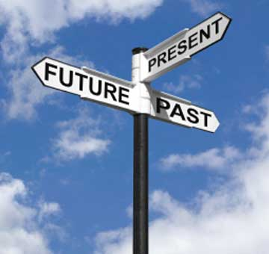

Understand the purpose and value of their learning and see its relevance to their past, present and future



Develop new skills through a variety of interesting contexts.

Develop a rich and deep subject knowledge.

We believe that children deserve a balanced curriculum that enables them to develop a deep understanding of all subjects and the interconnections between them. The rationale for the St. John’s curriculum, ‘Life in all its Fullness’, takes the form of 10 big ideas that provide a purpose for the aspects, skills, knowledge and contexts chosen to form the substance of the curriculum. These big ideas form a series of multi-dimensional interconnected threads across the curriculum, allowing children to encounter and revisit their learning through a variety of subject lenses. Over time, these encounters help children to build conceptual frameworks that enable better understanding of increasingly sophisticated information and ideas.

Our 10 big ideas are as follows:

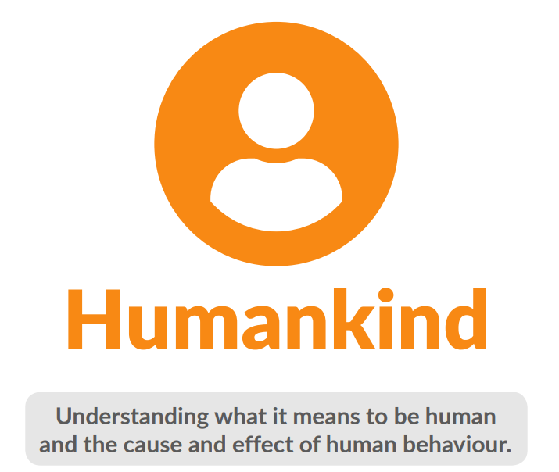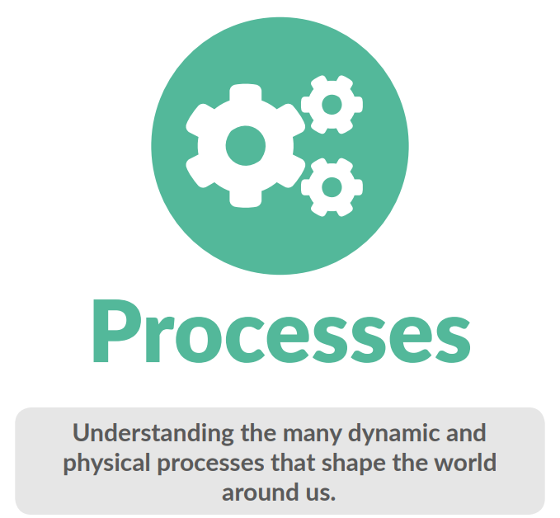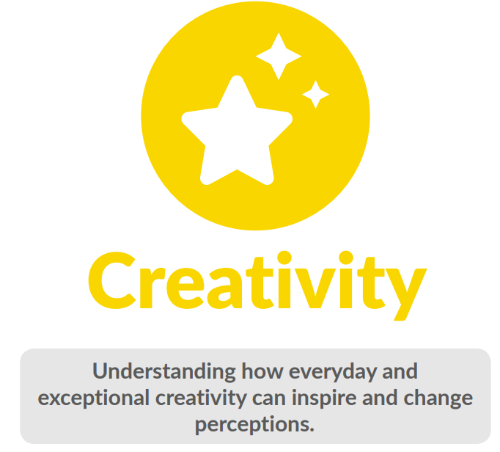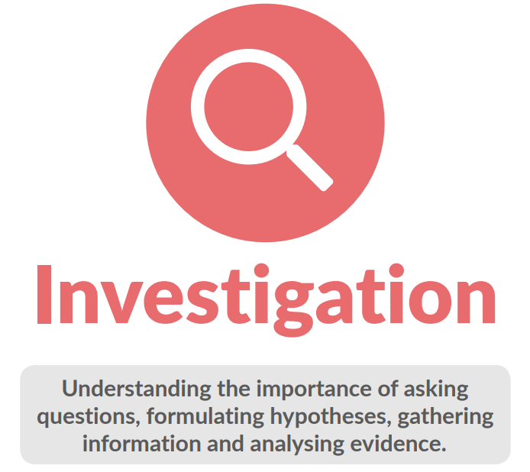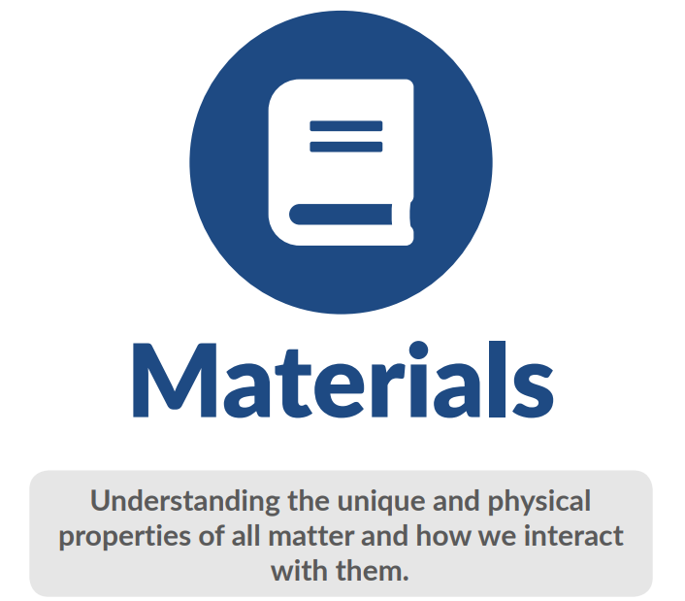

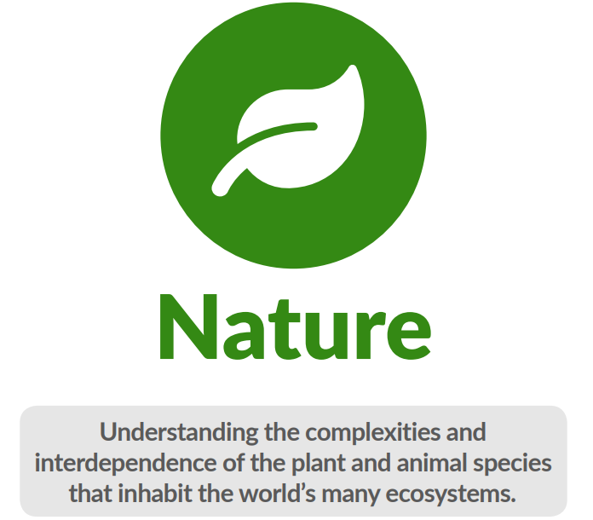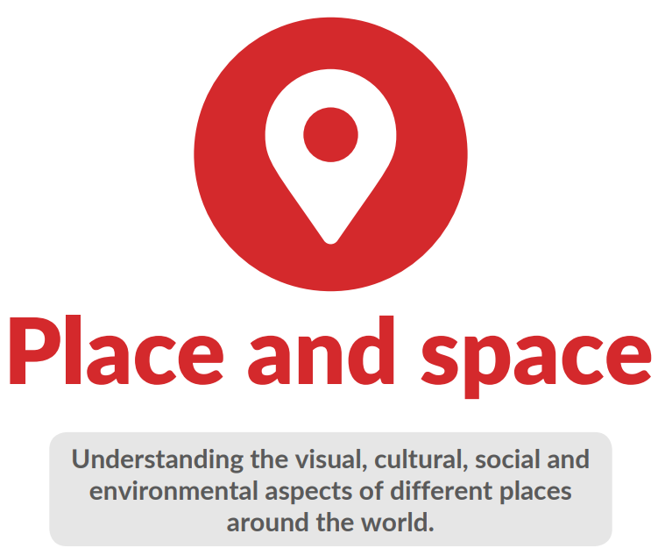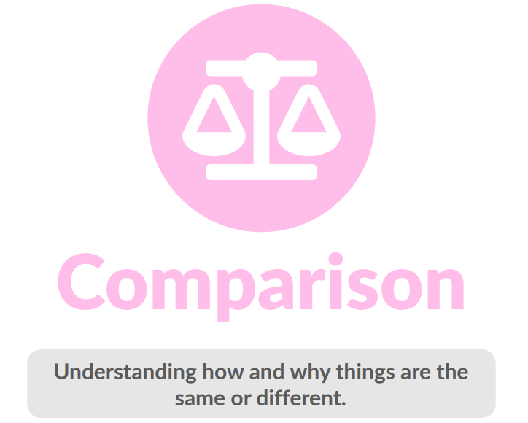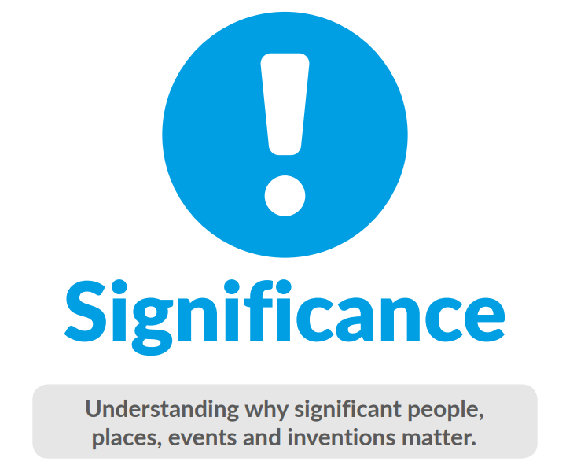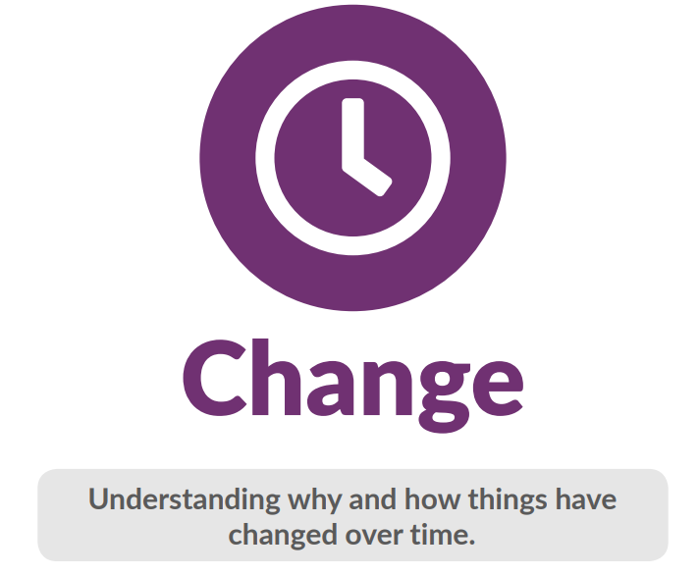

**Humankind**

Understanding what it means to be human and the cause and effect of human behaviour.

This big idea invites children to find out what it means to be human, including the workings of human anatomy and how to keep safe. They explore ways that the human race is interconnected and explore the human experience and identities through a range of subject lenses. They discover the cause and effect of human behaviour and develop an understanding of the relationships between individuals, societies, faiths and communities. Through this big idea, children discover the ancient secrets of past civilisations and see the multitude of ways in which they influence modern-day life.

**Processes**

Understanding the many dynamic and physical processes that shape the world around us.

This big idea invites children to find out about the diverse and dynamic physical processes that are present in, and have a significant impact on, places, the environment and the world around them. They explore the physics of force and movement and investigate the phenomena of electricity, light and sound. Through this big idea, children discover how physical processes such as weather and erosion can transform a place or landscape.

**Creativity**

Understanding how everyday and exceptional creativity can inspire and change perceptions.

This big idea invites children to discover the place of everyday and exceptional creativity, including the qualities of persistence, determination, originality and resilience that form the basis of the creative process. They explore different ways in which their ideas and imaginings can be realised and communicated, and pursue enquiry by asking questions and finding connections between seemingly separate ideas. Through this big idea, children develop an appreciation of the importance of experimentation, trial and error, original thought and self-expression.

**Investigation**

Understanding the importance of asking questions, formulating hypotheses, gathering information and analysing evidence.

This big idea invites children to be curious and search for answers in response to original, familiar and more complex questions. They explore ways to create hypotheses, gather evidence and begin to evaluate data. They experiment with different ways to present information and ideas and make informed choices to solve problems. Through this big idea, children start to think critically, make meaningful connections and reflect thoughtfully on evidence and ideas.

**Materials**

Understanding the unique and physical properties of all matter and how we interact with them.

This big idea invites children to explore the properties of all matter, including that which is living and non-living. It explores how materials are both formed and change. Through this big idea, children develop an understanding of the uses of materials and their unique, physical properties that make them fit for purpose.

**Nature**

Understanding the complexities and interdependence of the plant and animal species that inhabit the world’s many ecosystems.

This big idea invites children to find out about the diverse natural environments of the world and the plethora of species, both plant and animal, that live in them. They explore the characteristics and features of a range of habitats and study how living things interact within them. They examine the effects of economic and technological development on the natural world and consider the impact of human actions. Through this big idea, children discover the conditions needed for living things to thrive and survive.

**Place and Space**

Understanding the visual, cultural, social and environmental aspects of different places around the world.

This big idea invites children to explore the visual, cultural, social, and environmental aspects of places in their locality and the wider world. They examine how human activity and social interactions shape places and enable them to discover the unique identities and features of towns, cities, countries and continents. Through this big idea, children develop an appreciation of both the natural and urban landscape and begin to understand the bond between people and place or setting.

**Comparisons**

Understanding how and why things are the same or different.

This big idea invites children to compare ways that things are the same or different. They identify simple and more complex patterns and make connections. Through this big idea, children develop an understanding of different ways to represent data using classification systems, comparison tables or charts and hierarchical taxonomies.

**Significance**

Understanding why significant people, places, events and inventions matter.

This big idea invites children to explore the importance of significant people, places, events and inventions. They examine why things are meaningful to some and not to others, based on their values, beliefs and experiences. Through this big idea, children develop an understanding of key people, places, events and inventions that have changed their everyday lives and the world at large.

**Change**

Understanding why and how things have changed over time.

This big idea invites children to find out about the causes and consequences of change and evolution. They investigate and explore how events unfold and develop an understanding of timelines and chronology. Through this big idea, children begin to make meaningful connections between past, present and future and begin to appreciate the unique position of their place in time.

**How our Curriculum is Delivered:**

Each new area of learning from Year One through to Year six will be approached and planned in the same way. The children will first be part of a **memorable experience** before moving onto lessons planned to **engage** them, they will next **develop** their understanding before being given the opportunity **to innovate**. Finally, an opportunity to **express** what they know will be provided.

Express

Innovate

Develop

Engage

Memorable

Experience

An example of this is the Year One History topic of ‘Childhood’. The topic follows the steps above in the following way:

**Memorable experience** – Visiting a local museum or exploring picture cards where historical childhood items are explored and discussed.

**Engage** – In this stage the children look at the stages of human life, timelines, Important events and finally, family trees.

**Develop –** In this stage the children will develop their knowledge within different times in history and how childhood might have looked quite different in each one.

**Innovate –** This is the stage where the children become ‘experts’ within the topic they have been learning about and apply that knowledge (with the support of their knowledge organiser) in different ways more independently.

**Express –** This is an opportunity for the children to prove what knowledge they have gained during the topic.

At the beginning of every topic in each subject the children will be introduced to a knowledge organiser that supports the ‘key knowledge’ the children will need to know for each subject area. These will be available in the classroom and on the class webpages.

Each subject is taught discreetly, and the children are told which subject they are learning and are encouraged to use the different subject names.

At the beginning of each term the class teacher has the responsibility of looking at the subject topics they are to teach. They are encouraged to approach the planning process in the following way:

* What ‘key knowledge do the children need to have acquired by the end of the term?
* What do the children already know (what have they previously been taught)?
* What will the children go on to learn next?
* What adaptations to the plans need to be made for the lessons to best suit the needs of the children in the specific class?
* How are the needs of children with a Special Educational Need being met in each lesson taught?

While planning for each lesson and resources are provided, it is the expectation that teachers use these resources as a tool and a vehicle to deliver the best quality lessons.

While English, Maths, PE, Computing, MFL, Music and People Skills are not taught using the ‘Big Ideas’ we would expect teachers to follow the same planning process for all subject areas.

**Foundation Stage**

Our foundation children will be taught through the Maestro curriculum tool and teachers will adopt a similar planning process. We expect that our children will gain knowledge and skills through child-centred, play based, well-planned activities.

**The Role of the Subject Leader**

The role of the subject leader is to:

* Provide a strategic lead and direction for the subject.
* Support and offer advice to colleagues on issues related to the subject.
* Monitor the quality of learning in the subject through book scrutiny, lesson visits, pupil voice and planning scrutiny.
* Ensure they have a good understanding of the ‘narrative’ of their subject.

The school gives subject leaders non-contact time each term to carry out the duties involved in their role.

**Monitoring and Review**

Our governing body is responsible for monitoring the way the school curriculum is being implemented. We have named governors for each subject area. They will meet with the subject leader at least once a year to gain an update on the subject.

The headteacher is responsible for the day-to-day organisation of the curriculum. The headteacher, with the support of members of SLT, will monitor planning and ensure that the full requirement of the National Curriculum is being upheld.

Subject leaders monitor the way their subject is taught throughout the school. They examine planning and ensure that appropriate adaptations are being made. Subject leaders have the responsibility for monitoring the way in which resources are stored, purchased and managed.

**Reviewed:** October 2023

**Review:** October 2025

**Reviewed by Staff:** K. Thrower

**Governor:**