

Class Two Residential Visit
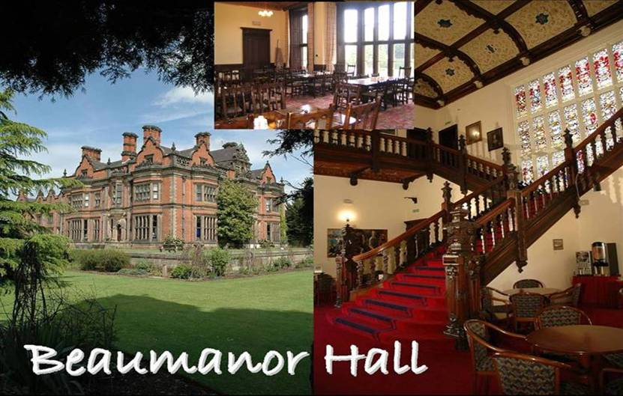
Beaumanor Outdoor Learning Centre

Wednesday 5th February –

Thursday 6th February 2025

Parent Information

St John the Baptist Church of England Primary School
Educational Visit to Leicestershire

Wednesday 5th February – Thursday 6th February 2025

Address

Beaumanor Outdoor Learning Centre
Beaumanor Drive,
Woodhouse,
Loughborough,
LE12 8TX
https://www.beaumanorhall.co.uk/schools-and-academies/

Telephone: 01509 890 119 – For EMERGENCY CALLS ONLY (9am to 5pm)
Telephone: 07743 162 461 – For EMERGENCY CALLS ONLY (5pm-9am)

Beaumanor Hall has been offering outdoor learning experiences for children in Leicestershire and the surrounding area since the 1970s. It caters for groups of children through from Foundation Stage through to post 16. The centre offers a range of experiences from adventurous activities to nature studies and themed days. The centre is run by Leicestershire County Council and is accredited by both the Council for Learning Outside the Classroom and the Adventure Activities Licensing Authority.

Our Year 2 residential is shared with Cotgrave Church of England Primary School, Cotgrave.

ACCOMMODATION

The centre has comfortable accommodation, with five cabins each with main dormitories, staff bedrooms, living and dining areas, kitchens, toilets and washing and showering facilities. The cabins are equipped with central heating and are set up to be self-catering, but evening meals are served in the Hall itself during the week. For this visit we will be allocated three of the cabins and will have sole use of our accommodation.

MEALS
The children are given two meals on each day at the centre. A typical menu would be:

Breakfast: cereals, toast, juice and fruit

Lunch: sandwiches, crisps, fruit, juice and a cake

Evening Meal: sausages, pizza, pasta, jacket potato, salad, ice cream/cookies/chocolate sponge

Staff Participating in this Visit

Miss Wilcox & Mrs Lowings (plus Cotgrave staff)

Behaviour
Our usual very high standards of behaviour will be expected at all times. Anyone who is proving a danger to themselves or others will have to be collected and taken home.

Medication
Please ensure that all necessary medication is clearly labelled with your child’s name and the dosage required. The medical form must be returned by Friday 31st January 2025. All medication must be handed directly to Mrs Lowingson the morning of the visit (or before).

Kit List
Old comfortable clothes are the order of the day.
We will be visiting in February, so plenty of warm clothing will be required!

- Sleeping bag
- Pillow (in pillow case)
- Toiletries
- Towel
- Nightwear
- Underwear (3 pairs)
- Thick socks (no trainer socks) (3 pairs)
- Torch
- Indoor footwear (must be worn inside the building)
- Bin bag for wet/dirty clothes
- Trousers eg. joggers - 3 pairs (no jeans as they hold the wet)
- Warm jumpers/tops – at least 3
- Waterproof jacket/trousers
- Hat, scarf, gloves (x2 pairs)
- T-shirts (3)
- Outdoor trainers
- Wellies
- Teddy / Soft toy
- Pirate Costume
- Water Bottle

The children should not bring: a packed lunch for the first day; any other food; any sweets; any money; anything electronic; anything of great value.

The above should be packed in a wheeled suitcase – there is quite a walk from the coach stop to the cabins so they need to be able to wheel it themselves. Please name all clothing, especially hats, gloves and scarves and ensure that packing is done with your child so that they know what they have got and where it is! The centre holds lost property for a short time after the visit. They cannot accept responsibility for visitor’s property; valuable items are brought at the owner’s risk.

For your reassurance, every single child that we have taken to Beaumanor Hall has always had an amazing time and wanted to stay longer, even those children a little unsure beforehand!

