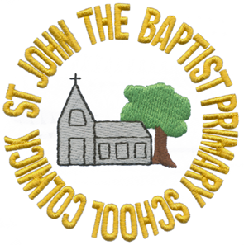
St John the Baptist C of E Primary School

Address: Vale Road, Colwick, Nottingham NG4 2ED
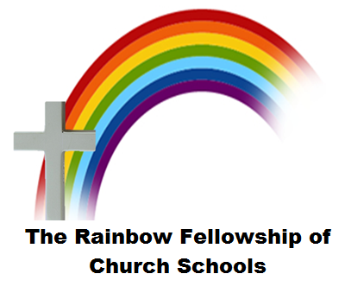
Tel: 0115 9115599
Email: office@st-johns-pri.notts.sch.uk
Website: www.st-johns-pri.notts.sch.uk

Head Teacher: Miss R Ireland

Pupil Premium Funding/ Free School Meals

Dear Parents/Carers,

We are writing to you to give you guidance on how to apply for Free School Meals for your child. As all children in Foundation Stage and Key Stage 1 now receive a school dinner, some children are missing out on additional funding called Pupil Premium funding as parents are not applying for it due to the fact that a free school dinner happens automatically for everyone.

If your child is eligible for Free School Meals, they will also get many other additional forms of support throughout their time at school. Any child who is entitled to Free School Meals also receives Pupil Premium Funding in addition to having their lunches paid for.

At St Johns, we use the Pupil Premium Funding (which is £1345 per year per child) to run our School Watch programme. This programme allows us to work with your child in a variety of ways including:

- Providing extra teacher support through booster sessions
- Providing one to one support for your child
- Purchasing resources to support children across the curriculum
- Funding breakfast club and after school activities
- Paying for some of the cost of school trips including residentials.

You are eligible for Free School Meals and Pupil Premium funding if you are in receipt of one or more of the following benefits:
- Universal Credit (provided you have an annual net earned income of no more than £7,400)
- Income Support
- Income-based Jobseeker’s Allowance (JSA)
- Income-related Employment and Support Allowance (ESA)
- Support under Part VI of the Immigration and Asylum Act 1999
- The guarantee element of Pension Credit
- Child Tax Credit (with no Working Tax Credit) with an annual gross income of no more than £16,190
- Working Tax Credit run –on (paid for the four weeks after the person stops qualifying for Working Tax Credit)
These benefits have now been rolled into a single benefit, called the Universal Credit. From April 2018 Free School Meals and Pupil Premium will only be allocated to pupils with a family income under £7400 (net) per year.

To apply for Free School Meals and Pupil Premium funding:
- Phone 0300 500 8080
- Visit https://www.nottinghamshire.gov.uk/education/school-meals/free-school-meals-and-milk
- Speak to the school office

The information you will need to make an application is:
- National Insurance Number or National Asylum Support Service Reference Number
- Surname
- Date of birth

Once you apply for Free School Meals, even if your circumstances change, your child will continue to receive the Pupil Premium for the entire time they are at our school.

Why should I apply?
I will only be asked to pay a contribution towards school trips rather than the whole cost.
My child will receive a free school meal.
My child will be supported by one of the Booster teachers in school.
My child may have access to new resources.

If you have any question about Pupil Premium funding, please call school and speak to myself or Miss Ireland.

Many thanks

Mrs F Belton (Pupil Premium Lead)

