**HAVE YOU SEEN THIS PERSON?**

**Ha**

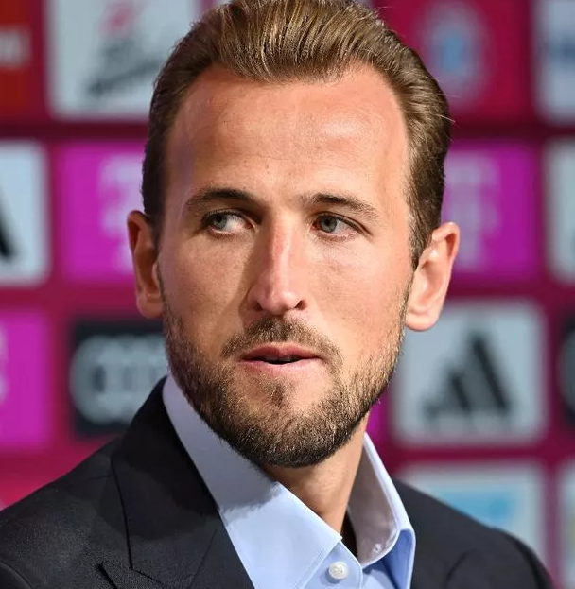

**Harry Kane**

**Character traits: Resilience**

**Context:.** He might be regarded as one of the best footballers of his generation, but the 30-year-old striker admits: “I’ve had many challenging times throughout my life and my career.” And in those times, he has sought support. He says: “Connecting and talking to my friends, family and teammates is key for me.”

In the Here4You film he videoed to support schoolkids across the UK, Harry tells youngsters to get help if they feel low. He says: “Life is full of experiences that sometimes we don’t have control over. As we go through tough times, we learn more about ourselves and build resilience. But most often we can’t do this alone and need the support of others.”