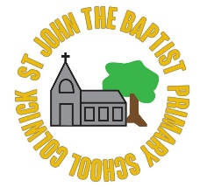
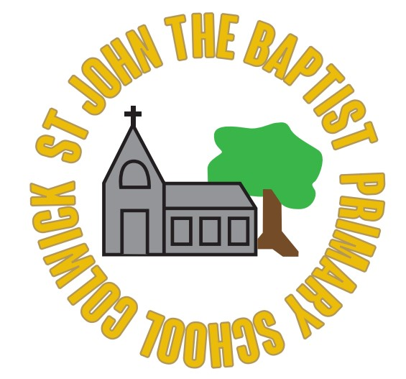St John the Baptist C of E Primary School
History Vocabulary List
Foundation Class
today | yesterday | tomorrow
the present | The past | The future
day | week | month
long ago | old | new / recent
parent | grandparent | remember
history | memory | lifetime
calendar | Who? | What?
Class 1
year | decade | century
ancient | modern | living memory
timeline | date order | Remembrance
similar | different | grandparent’s time
the older generation | memories | photographs
Queen Elizabeth 1 | William Shakespeare | Goose Fair
Who? | What? | When?
Where? | artefact | Ice Age
millions of years ago | Stone Age | thousands of years ago
Neolithic | hunter-gatherer | Bronze Age
Stonehenge | Iron Age | hill forts
Class 2
anachronism | chronological order | era/period
investigate | research | evidence
Why? | historian | artefact
detective | opinion / fact | experts
Great Fire of London | Samuel Pepys | diary
Pudding Lane | plague | Black Death
Christopher Wren | St Paul’s Cathedral | Florence Nightingale
sanitation | Lady with the Lamp | Crimean War
Ancient Egypt / Egyptians | The Nile | First civilisations
North Africa | tomb | Pharoah
Pyramids | Tutankhamun | Howard Carter
Sphinx | gods/goddesses | mummification
Remembrance | memorial | local history
Nottingham Castle | Nottingham Caves | Old Market Square
Wollaton Hall | Sherwood Forest | eyewitness
Class 3
anachronism | chronological order | era/period
artefact | first hand evidence | second hand evidence
reliability | research | early photography
Who, what, where, why, how? | eyewitness | compare/contrast
B.C.E (Before Common Era) | C.E (The Common Era) | B.C. (Before Christ)
A.D (Anno Domini) | millennium | Romans
Roman Empire | civilisation | Julius Caesar
invasion | Emperor | Army / Centurion
Boudicca | Hadrian’s Wall | Romanisation
Pompeii | Mt Vesuvius | mosaic
inventions | gods / goddesses | archaeology (-gist)
The Victorians | Queen Victoria | The Industrial Revolution
child labour | mills/factories | slums
reformers | legislation | workhouse
inventions | railways | seaside holiday
Victorian schools | punishment | compare / contrast
Class 4
anachronism | chronological order | era/period
cause / effect | consequences | culture
change | continuity | historian
Who, what, where, why, how? | primary evidence | secondary evidence
validity | archaeology (-gist) | artefact
B.C.E (Before Common Era) | C.E (The Common Era) | B.C. (Before Christ)
A.D (Anno Domini) | millennium | Anglo-Saxons
Roman withdrawal | invasions | settlements
kingdoms | Sutton Hoo | Runes
Anglo-Saxon Gods: Tiw - Tuesday, Woden - Wednesday, Thunor – Thursday, Frige - Friday
myths and legends | Beowulf | Legend of King Arthur
Christian conversion | monasteries | Lindisfarne
Viking invasions | pagans | warrior
Alfred the Great | Athelstan | Edward the Confessor
Danegeld | longship / dragon-ships | Jorvik
Berserker | Norse mythology | Erik the Red
Maya | civilisation | MesoAmerica
dynasty | empire | glyphs
codices | cacao | Ahau / Ahaw
maize | warrior | temple
Chichen Itza | Tikal | worship
Itzamna | huipil | Kukulcan
Class 5
anachronism | chronological order | era/period
impact | effect | consequences
Who, what, where, why, how? | primary evidence | secondary evidence
compare / contrast | to weigh up both sides | on one hand / other hand
eyewitness | infer | suggest
continuity | change | historian
validity | archaeology (-gist) | artefact
source | This source suggest that… | This source doesn’t show…
Ancient Greeks | influence on western world | achievements
Parthenon | Acropolis | temple
Greek gods/goddesses | Mount Olympus | Athens
amphitheatre | odeon | Pythagoras
Archimedes | philosopher | pottery / amphora
hoplite / hoplon | phalanx | trireme
Olympia / Olympics | Greek myths / legends | Pandora’s Box
The Tudors | Henry VII | Battle of Bosworth
Henry VIII | Henry VIII’s six wives | Tudor Houses
Shakespeare | Spanish Armada | Sir Francis Drake
Queen Elizabeth I | The Age of Exploration | Christopher Columbus
Hernándo Cortés | conquistador | smallpox
Class 6
anachronism | chronological order | era/period
impact | effect | consequences
Who, what, where, why, how? | primary evidence | secondary evidence
compare / contrast | to weigh up both sides | on one hand / other hand
eyewitness | I can infer that… | suggest
continuity | change | historian
validity | archaeology (-gist) | artefact
source | This source suggest that… | This source doesn’t show…
20th Century | World War I | World War II
Adolf Hitler | Nazi | Swastika
blackout | The Blitz | air raid shelter
evacuee | Ration book | gas mask
Home Guard | Gestapo | propaganda
Jew | Star of David | Concentration camp
Conscription | Victoria Cross | Spitfire
Neville Chamberlain | Winston Churchill | Anne Frank
Allies | Atomic bomb | D-Day
Greta Thurnberg | Mark Zuckerberg | Steve Jobs
Coronavirus | Covid-19 | Lockdown
Boris Johnson | Chris Whitty | vaccine
self-isolation | social distancing | pandemic

