Friday 22nd May
Design and Technology Day
Please choose which technology task you would like to carry out today. Task A or Task B.
Task A | Task B
Design and create your own food product e.g cakes, fruit salad, quiche, cookies.  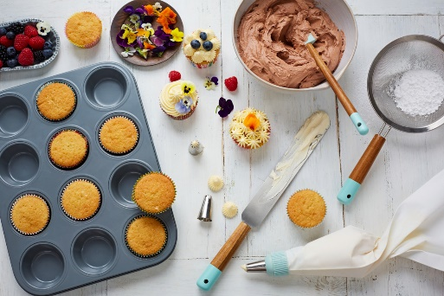  You must:  - Complete a design before beginning to create your product.  - Write a list of ingredients with the measurements you will use.  - Write a list of equipment you will use.  - Take a picture of your final product.  - Eat and evaluate your creation. In your evaluation think about what went well and how your product could be improved next time.  - Send a picture of your product, original design and written evaluation to your class teacher. | Moving recycled model.  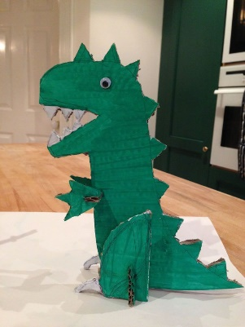  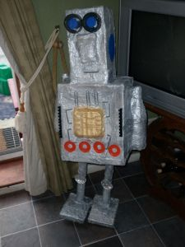  Using materials you find in your recycling create a moving model. Think about different resources you could use to connect pieces together and the tools you may need to do this.  You must:  - Complete a design before beginning to create your model.  - Write a list of resources you will use, e.g. cereal box, kitchen roll tube.  - Write a list of equipment you will use e.g. scissors, saw.  - Take a picture of your final product.  - Evaluate your product. In your evaluation think about what went well and how your model could be improved next time.  - Send a picture of your model, original design and written evaluation to your class teacher.

You may wish to lay your design and evaluation out in a similar way to this
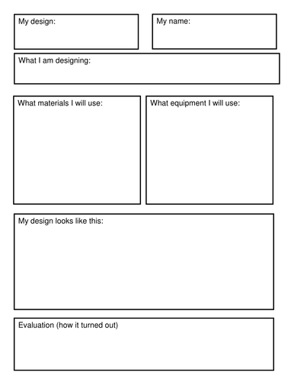
Please send your photos to your teacher. Mrs Bloom will then choose a winner for Task A and Task B from each Key Stage. Winners will collect their prizes at a later date. Good luck everyone! Winners will be announced on Monday 1st June.

